Load Prism_Entry.mbx

Either double click on file or load through MapInfo.

Ensure buttons are loaded.
View three buttons pad below tool bar.

Ensure Mapinfo file Approved_Planning_template.tab is open.

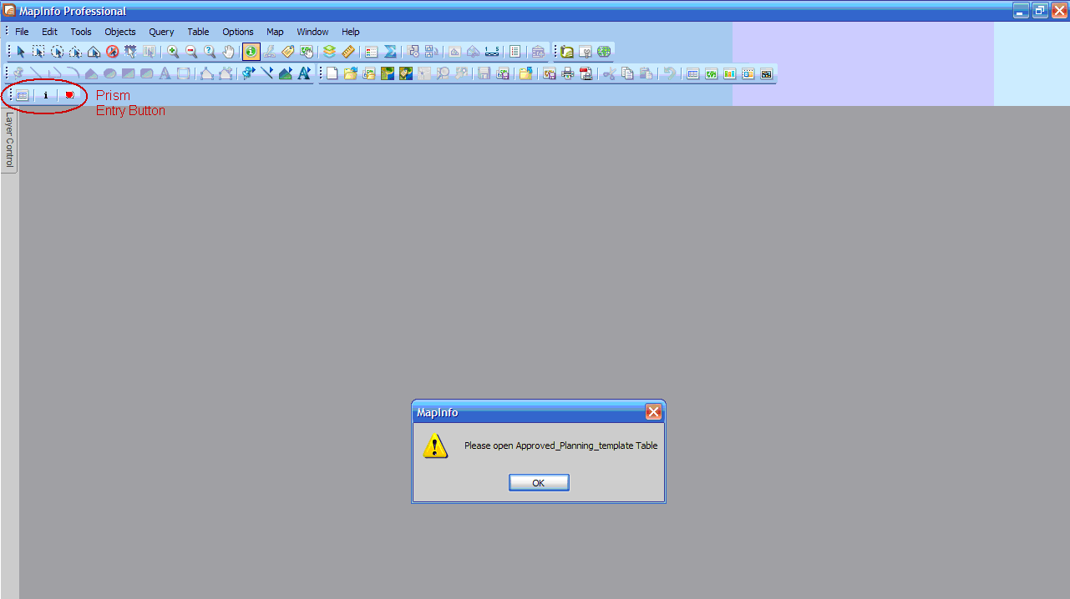

Make Approved_Planning_template.tab editable open. Create spatial data i.e Extents of Planning.

Select Update Approved Planning Template button

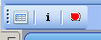

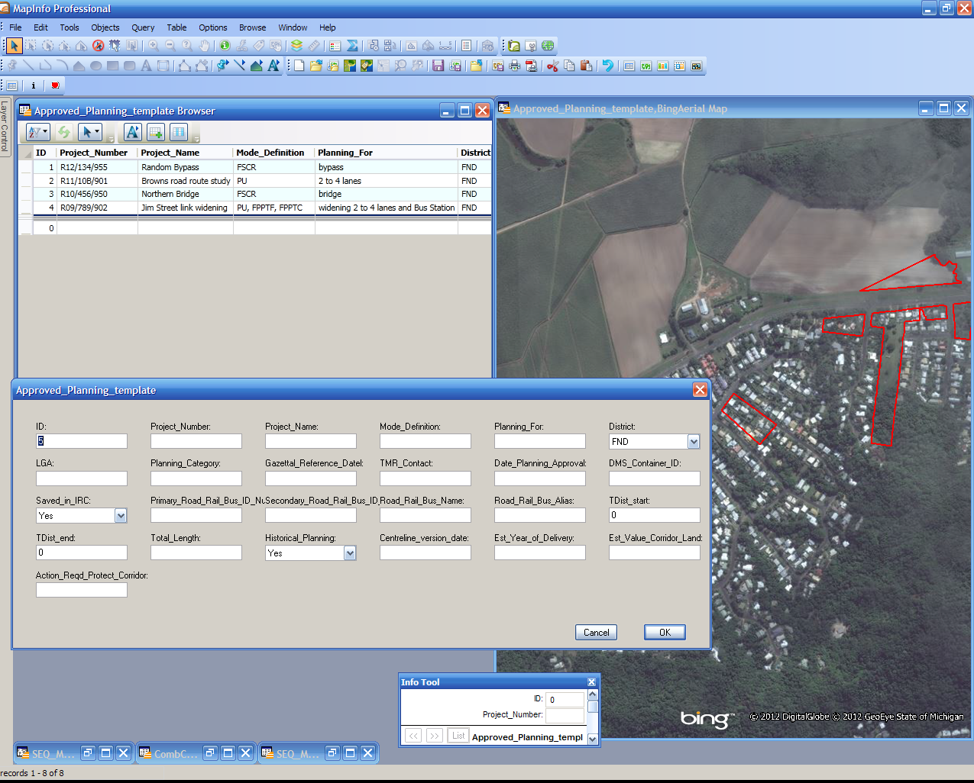

Fill in dialog, when you happy with input select Ok.

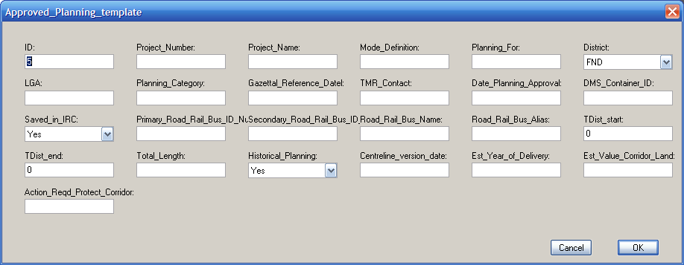

Any issues or request please contact.

John Worrall
Spatial Scientist (GIS) | Geospatial, Road Assets & Design
Engineering & Technology | Department of Transport and Main Roads

Floor 19 | 313 Adelaide Street
GPO Box 1412 | Brisbane Qld 4001
P: (07) 30660940 | F: (07) 30668998
E: john.a.worrall@tmr.qld.gov.au
W: www.tmr.qld.gov.au

